TextVenturer

Use-Case Specification: get inventory

Version <1.0>

Revision History

|  |  |  |  |
| --- | --- | --- | --- |
| **Date** | **Version** | **Description** | **Author** |
| <01/NOV/16> | <1.0> | First Uploaded | André Schmitt |
| <07/DEC/16> | <1.001> | Correct some things | André Schmitt |
|  |  |  |  |
|  |  |  |  |

Table of Contents

1. Use-Case Name 4

1.1 Brief Description 4

2. Flow of Events 4

2.1 Basic Flow 4

2.2 Alternative Flows 5

2.2.1 amount of inventory zero 5

3. Special Requirements 5

4. Preconditions 5

5. Postconditions 5

6. Extension Points 5

Use-Case Specification: Get inventory

# Use-Case Name

## Brief Description

This is our UC Diagram which starts if you type in get inventory

# Flow of Events

## Basic Flow



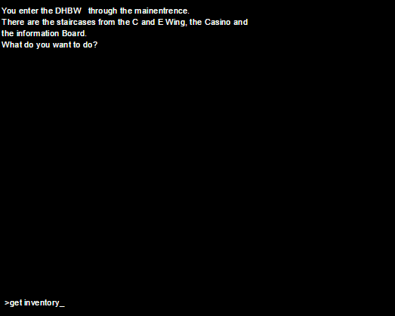

## Alternative Flows

### amount of inventory zero

If the number of things in your inventory is zero it Outputs “there is nothing in your Inventory”

# Special Requirements

n/a

# Preconditions

n/a

# Postconditions

Wait for next input

# Extension Points

n/a